Sara Wally’s

Helping Hands, Helping Hearts

Sw4h.org

[susiewally@yahoo.com](mailto:susiewally@yahoo.com)

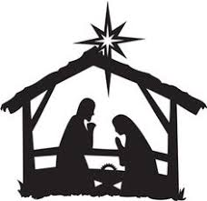

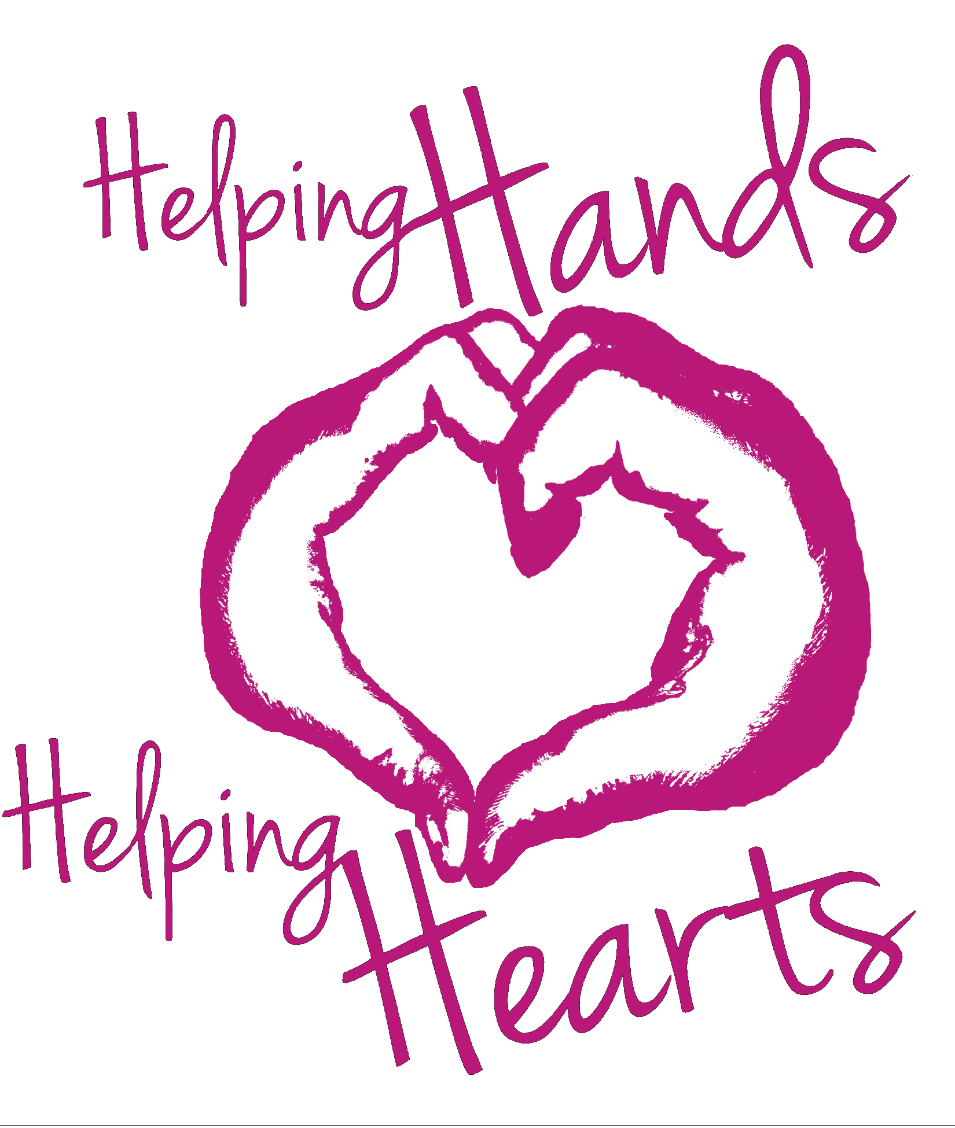

*During the season of giving, while you are baking Christmas cookies for family and friends, don’t forget to add two or more dozen for our homeless friends.*

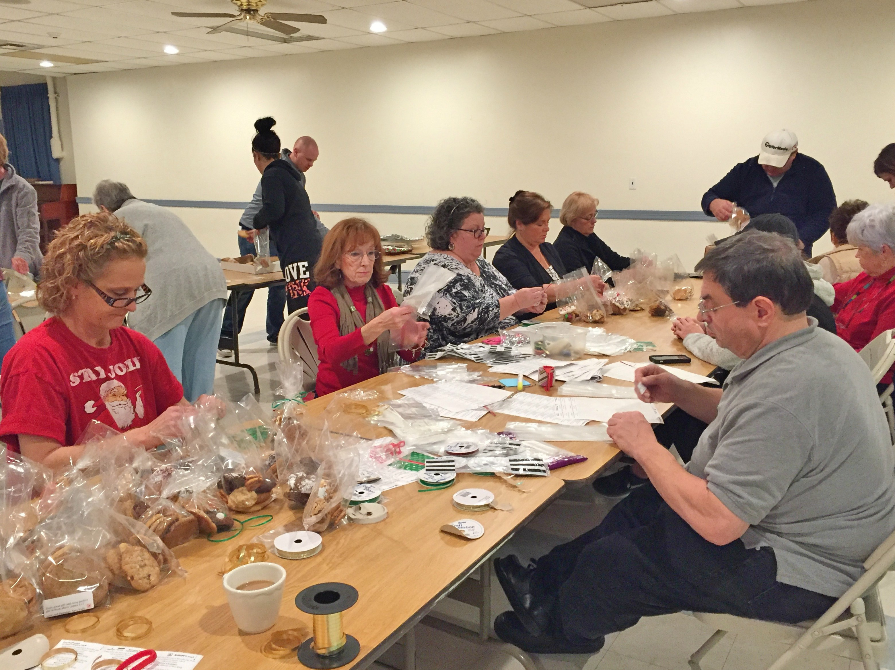

*My command is this:*

*Love each other as I have loved you.*

John 15:12

**December 12th 2019**

Sara Wally’s

8TH aNNUAL CHRISTMAS cOOKIES

for the Homeless

It’s that time of year again when you have the opportunity to make a difference in someone’s Christmas - just by baking your favorite Christmas cookies! These cookies will be distributed to homeless shelters throughout the Pittsburgh area.

You have 2 options for your cookie drop offs:

1. Any day before December 12th, cookies can be dropped off at the

Walendziewicz residence:

2408 Columbia Avenue

Pittsburgh PA 15218

1. On Thursday December 12, 2019, we will be accepting cookie drop offs from 5:30 PM - 8:00 PM at:

Hebron Church, Frankstown Road

Penn Hills, PA 15235 or

** We ask that you bring your cookies in non-returnable containers or, as you drop them off, you can take your container with you.